**Dynamic Charting**

**Prepare and Present a Dynamic Chart by using Dash Board, Vlookup, Match and Pivot Table**

**Task #1 Dash Board Creation**

1. Type the title of Four Subsidiaries from B3 to B6
2. Type the term Subsidiary in A9
3. Copy and Paste the Parameters of the Subsidiaries from Data to D3 to D7
4. Type the Term Parameter in C9
5. Copy and Paste Special Transpose the Year from F3 to F8
6. Create Dash board drop down menu for each this.
7. Go to Data Tab - Data Validation - Allow List - Select the Four Subsidiaries, Parameters and Year for List
8. Organize the data in organize data worksheet for dash board presentation
9. Under the Organize data worksheet create a database with the following headers: Lookup Value, Subsidiary, Parameter, Year 2010,2011,2012,2013,2014,2015
10. In Lookup Value cell either Concatenate the Subsidiary & Parameter or Use the formula = B6&" "&C6 for combine the two fields
11. Go back to Dashboard Worksheet Create two fields below the dash board parameters - Year and Use combine Concatenate the Subsidiary & Parameter or =B9&" "&D9 as similar like done in the Organize data worksheet
12. Link the any one the year from the data base below the Year field and extend it for three more years
13. For getting the value under the Combine parameter use Vlookup function
14. =Vlookup(Lookup Value(Combined Parameters-C11), Table from Organized Data Worksheet (A5:I25), Match(Year field as lookup Value(B12), Lookup table from Organized data first row (A5:I5), Exact Match (0))
15. Vlookup = VLOOKUP($C$11,'Organize Data'!$A$5:$I$25,MATCH(Dashboard!B12,'Organize Data'!$A$5:$I$5),0)

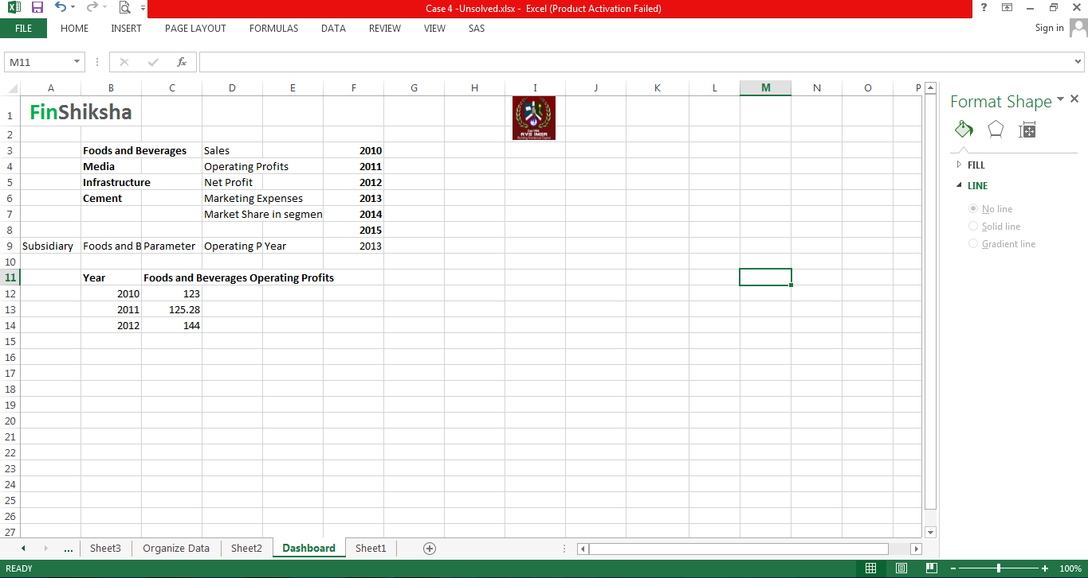

**Task # 2. Dynamic Chart from Dash Board**

1. Select the entire table go to Insert tab select 2D Line Chart for presentation
2. Right click and edit the data - X Axis as Year and Y Axis as per the Parameter Chosen

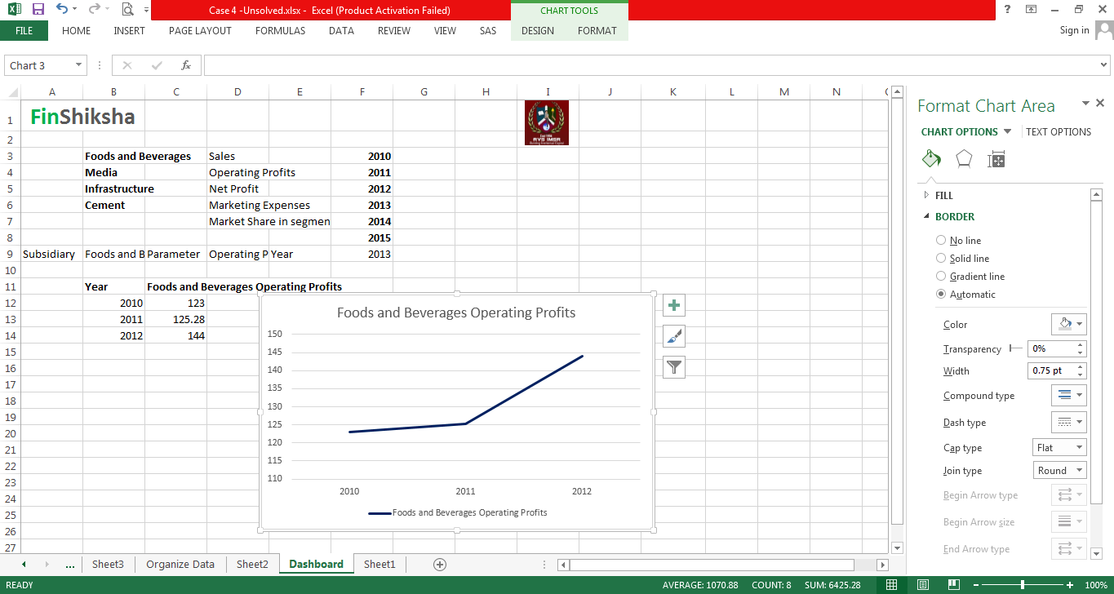

**Task #3 Dynamic using Pivot Table**

1. Use Pivot Table and Pivot chart for multiple subsidiary and multiple parameter together in one chart
2. Go to Organized Data and Select the entire data base(B5 to I25) except lookup value field (A5:A25)
3. Click Insert Tab – Select Pivot Table and Create Pivot Table in New Work Sheet
4. Select and Put Subsidiary in to Columns, Parameters in to Rows, Years 2010, 2011, 2012 in to Values.
5. For Multiple representation in Row wise pull the ΣValues from Columns push it to Rows
6. Go Row Label Click the small drop down menu (filter) for Selecting the Particular parameters
7. To remove the Grand total of columns – right click anywhere from the Pivot table – Select Pivot table options – Select totals & filters and click & remove the show grand totals for columns click OK and format the data set
8. For displaying the Pivot Chart – Click on Pivot table tools – Click on Pivot Chart and Select appropriate chart for representation
9. Use filter drop down menu in the Pivot chart for showing different parameter together on the same time.

